Task 1: Execute all yaml files shown in video.

STEP 0: Start Kubernetes Cluster
If using Minikube:
minikube start
If using EC2 / kubeadm cluster:
kubectl get nodes
Make sure at least 1–2 nodes are Ready

STEP 1: Check Nodes
kubectl get nodes -o wide
Example output:
node1 Ready
node2 Ready
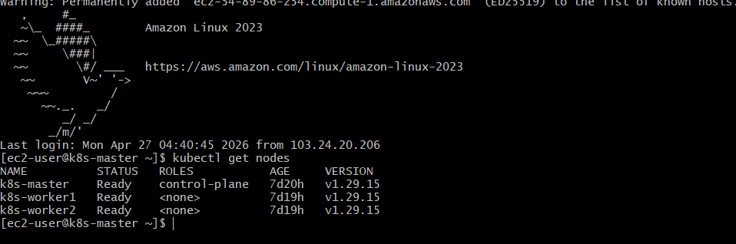

STEP 2: Add Labels to Node (IMPORTANT)
We assign labels so pods can target nodes.
kubectl label nodes k8s-worker1 disktype=ssd
kubectl label nodes k8s-worker2 env=prod

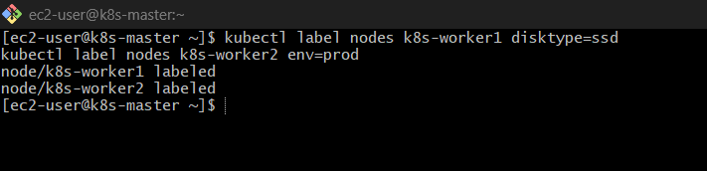
Verify:
kubectl get nodes --show-labels
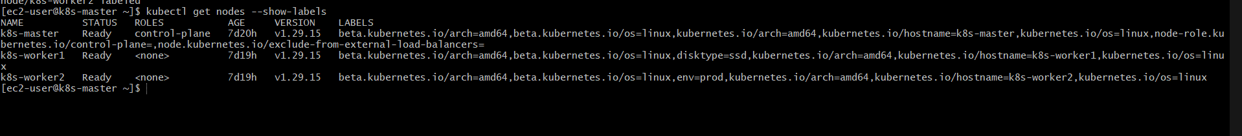

STEP 3: Create NodeSelector Pod
Create file:
vi nodeselector.yaml
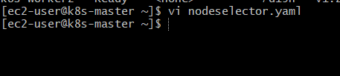
Paste:
apiVersion: v1
kind: Pod
metadata:
name: nodeselector-pod
spec:
containers:
- name: nginx
image: nginx
nodeSelector:
disktype: ssd
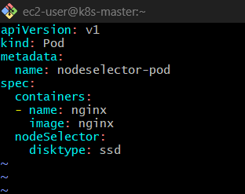
Run:
kubectl apply -f nodeselector.yaml
kubectl get pods -o wide
Pod will run only on node1 (ssd)
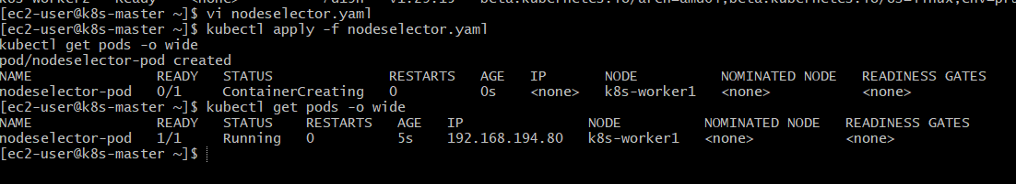

STEP 4: Create NodeAffinity Pod
vi nodeaffinity.yaml
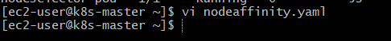
Paste:
apiVersion: v1
kind: Pod
metadata:
name: nodeaffinity-pod
spec:
containers:
- name: nginx
image: nginx
affinity:
nodeAffinity:
requiredDuringSchedulingIgnoredDuringExecution:
nodeSelectorTerms:
- matchExpressions:
- key: env
operator: In
values:
- prod
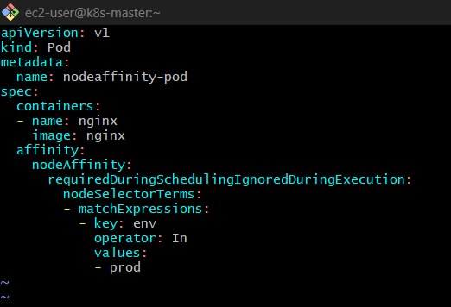
Run:
kubectl apply -f nodeaffinity.yaml
kubectl get pods -o wide
Pod runs only on node with env=prod
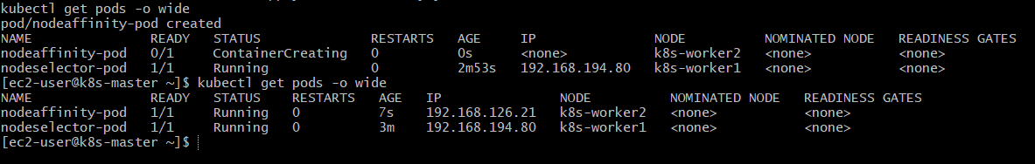

STEP 5: Apply Taint to Node
kubectl taint nodes k8s-worker2 env=prod:NoSchedule
Meaning: No pod can schedule here
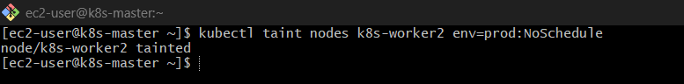
Check:
kubectl describe node k8s-worker2 | grep Taint

STEP 6: Create Toleration Pod
vi toleration.yaml
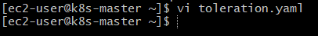
Paste:
apiVersion: v1
kind: Pod
metadata:
name: toleration-pod
spec:
containers:
- name: nginx
image: nginx
tolerations:
- key: "env"
operator: "Equal"
value: "prod"
effect: "NoSchedule"
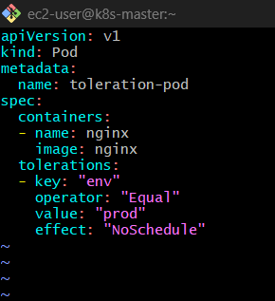
Run:
kubectl apply -f toleration.yaml
kubectl get pods -o wide
This pod WILL run on tainted node2
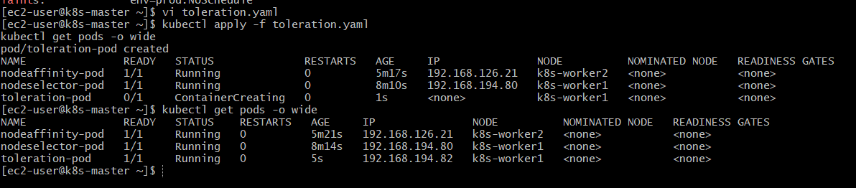

STEP 7: Verify Everything
kubectl get pods -o wide
kubectl describe pod nodeselector-pod
kubectl describe pod nodeaffinity-pod
kubectl describe pod toleration-pod

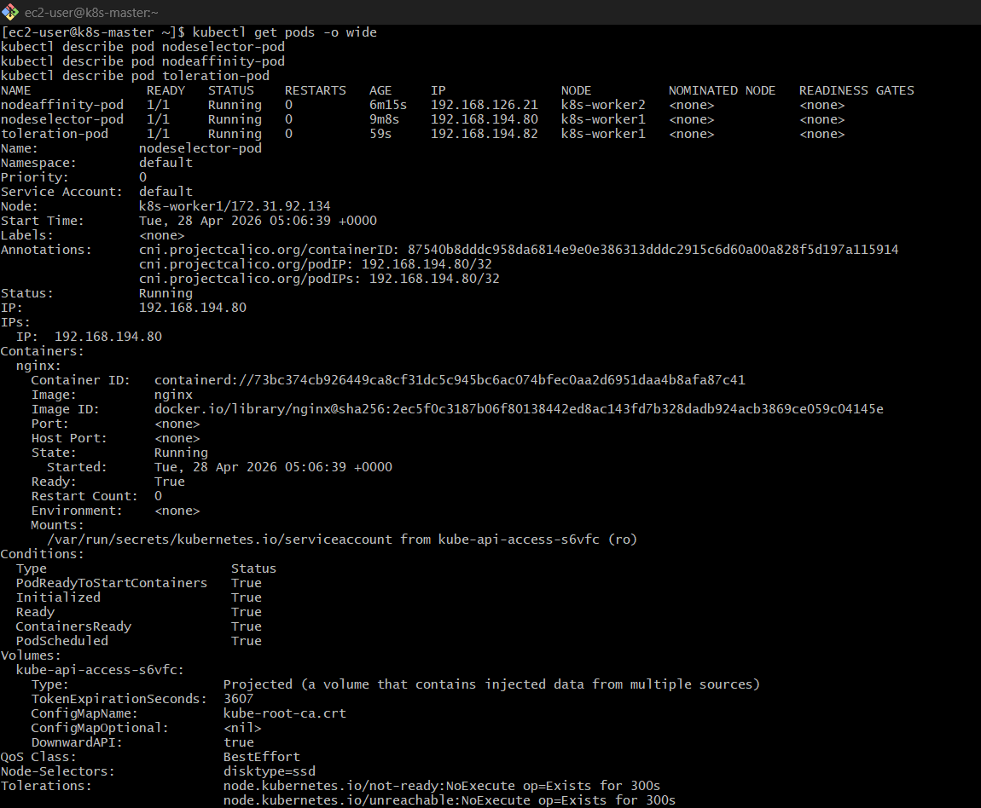
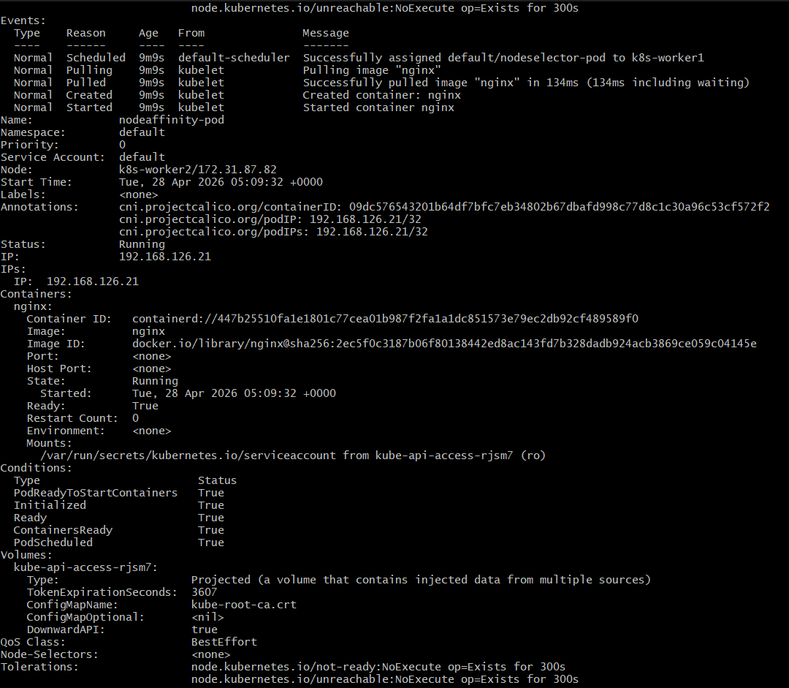
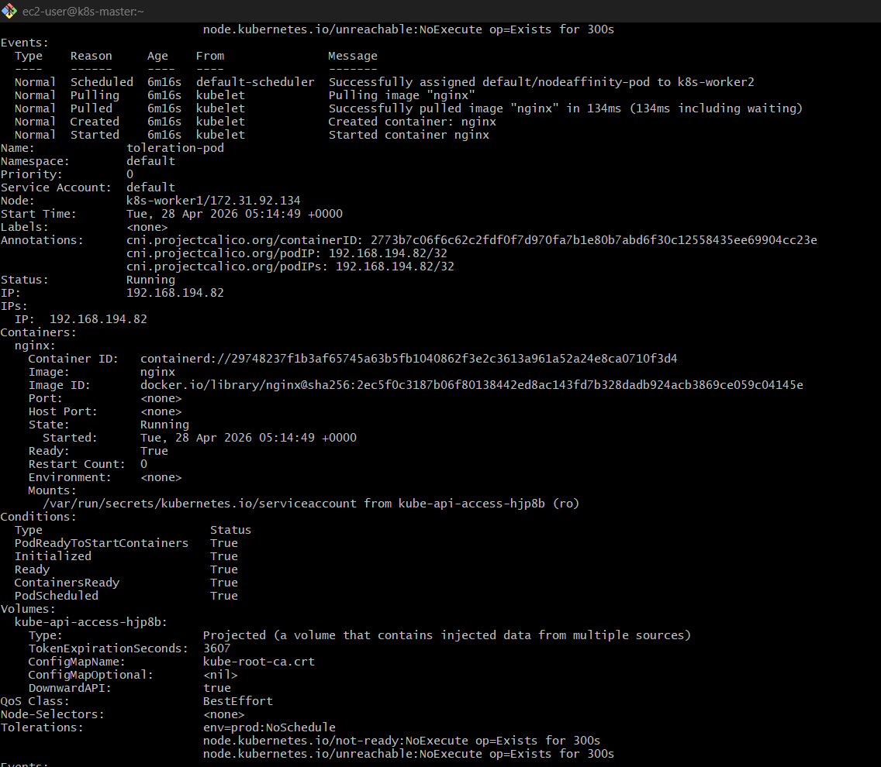
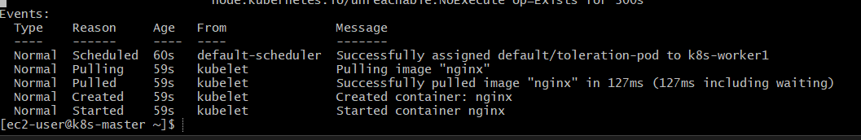

STEP 8: Cleanup (Optional)
kubectl delete pod nodeselector-pod
kubectl delete pod nodeaffinity-pod
kubectl delete pod toleration-pod
kubectl taint nodes node2 env=prod:NoSchedule-

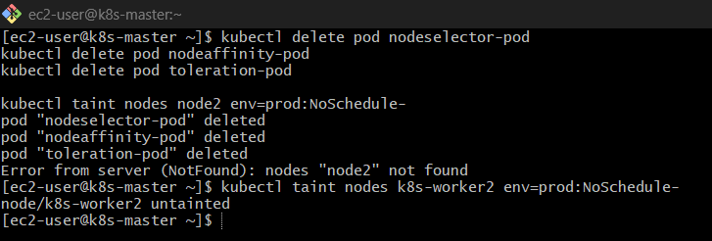

FINAL UNDERSTANDING
- NodeSelector → basic filtering
- NodeAffinity → advanced filtering
- Taints → block nodes
- Tolerations → allow pods

Task 2: Taint a Node and Schedule a Tolerant Pod Taint a node with special=true:NoSchedule. Create a pod with a toleration that matches the taint, allowing it to be scheduled on the tainted node.

Task: Taint a Node & Schedule a Tolerant Pod

Step 1: Check available nodes
kubectl get nodes
Note down one node name (example: k8s-worker2)
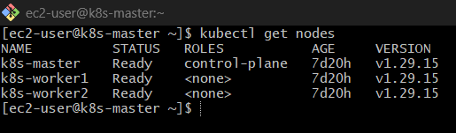

🔹 Step 2: Apply Taint to Node
Syntax:
kubectl taint nodes <node-name> key=value:effect
Your task:
kubectl taint nodes k8s-worker2 special=true:NoSchedule
Now this node will NOT accept any pods unless they tolerate this taint.
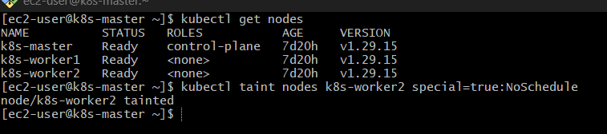

🔹 Step 3: Verify Taint
kubectl describe node k8s-worker2 | grep -i taint
Output should show:
special=true:NoSchedule

🔹 Step 4: Create Pod YAML with Toleration
Create file:
vi tolerant-pod.yaml
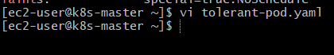
Paste this:

apiVersion: v1
kind: Pod
metadata:
name: tolerant-pod
spec:
containers:
- name: nginx
image: nginx
nodeSelector:
kubernetes.io/hostname: k8s-worker2 # 👈 force node
tolerations:
- key: "special"
operator: "Equal"
value: "true"
effect: "NoSchedule"
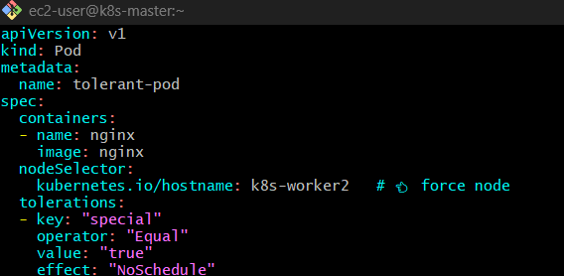

🔹 Step 5: Apply Pod
kubectl apply -f tolerant-pod.yaml
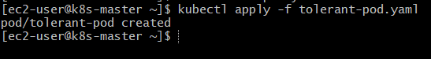

🔹 Step 6: Check Pod Status
kubectl get pods -o wide
You should see the pod scheduled on:
k8s-worker2

🔹 Step 7: Verify Scheduling
kubectl describe pod tolerant-pod
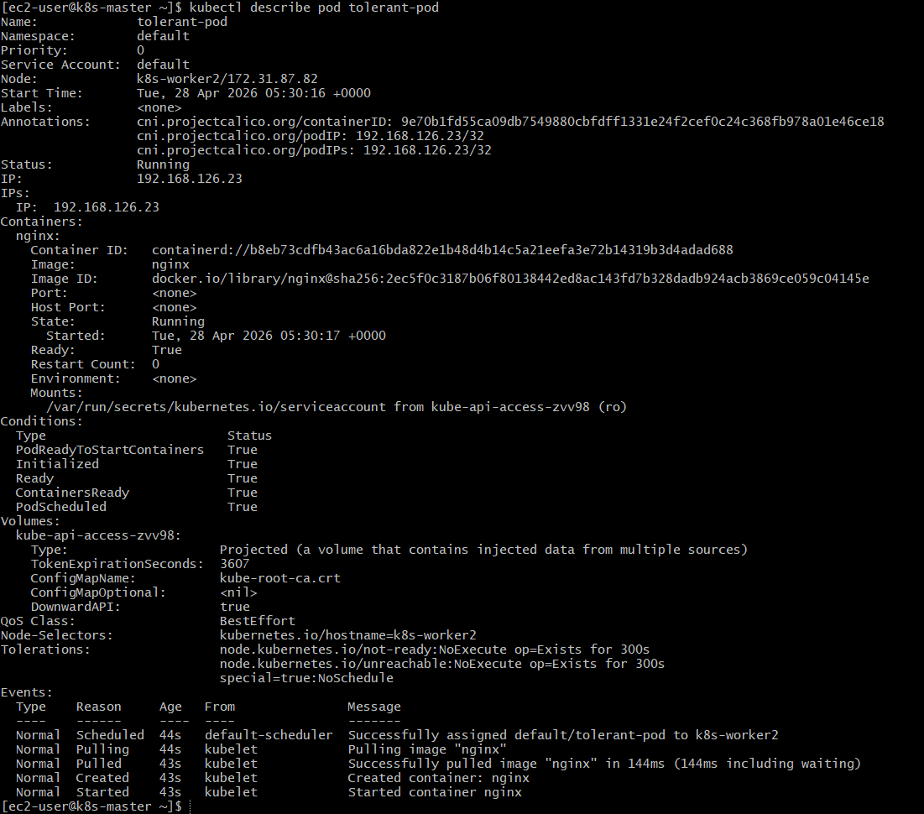

Look for:
Node: k8s-worker2

Important Concept
Concept |  |  |  | Meaning
Taint |  |  |  | Blocks pods from scheduling
Toleration |  |  |  | Allows pod to ignore taint
NoSchedule |  |  |  | Pod won’t schedule unless tolerated

❌ Bonus: What happens without toleration?
If you create a normal pod:
apiVersion: v1
kind: Pod
metadata:
name: normal-pod
spec:
containers:
- name: nginx
image: nginx
It will stay in:
Pending ❌

Cleanup (Optional)
kubectl delete pod tolerant-pod
kubectl taint nodes k8s-worker2 special=true:NoSchedule-

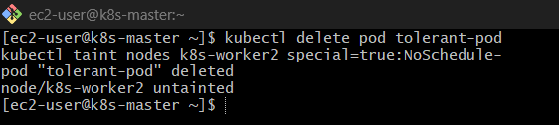

Task 3: Use NodeSelector to Schedule a Pod on a Specific Node Label a node with env=dev. Create a pod with a nodeSelector that schedules it only on the node labeled env=dev.

Task: Schedule Pod using NodeSelector

Step 1: Check Nodes
kubectl get nodes
Pick a node (example: k8s-worker1)
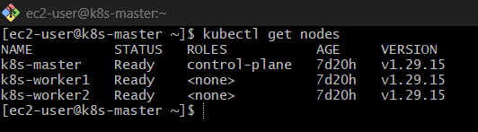

🔹 Step 2: Label the Node
Syntax:
kubectl label nodes <node-name> key=value
Your task:
kubectl label nodes k8s-worker1 env=dev
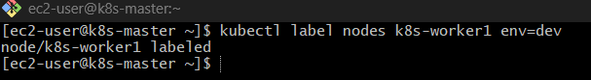

🔹 Step 3: Verify Label
kubectl get nodes --show-labels
You should see:
env=dev

🔹 Step 4: Create Pod YAML
vi nodeselector-pod.yaml
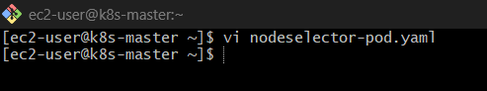
Paste this:
apiVersion: v1
kind: Pod
metadata:
name: nodeselector-pod
spec:
containers:
- name: nginx
image: nginx
nodeSelector:
env: dev
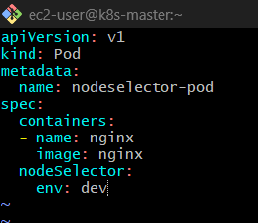

🔹 Step 5: Apply Pod
kubectl apply -f nodeselector-pod.yaml
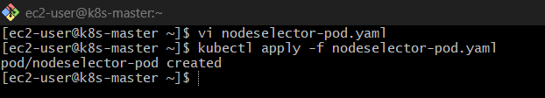

🔹 Step 6: Verify Scheduling
kubectl get pods -o wide
Output should show:
nodeselector-pod Running ... k8s-worker1 ✅

🔹 Step 7: Deep Verify
kubectl describe pod nodeselector-pod
Look for:
Node: k8s-worker1
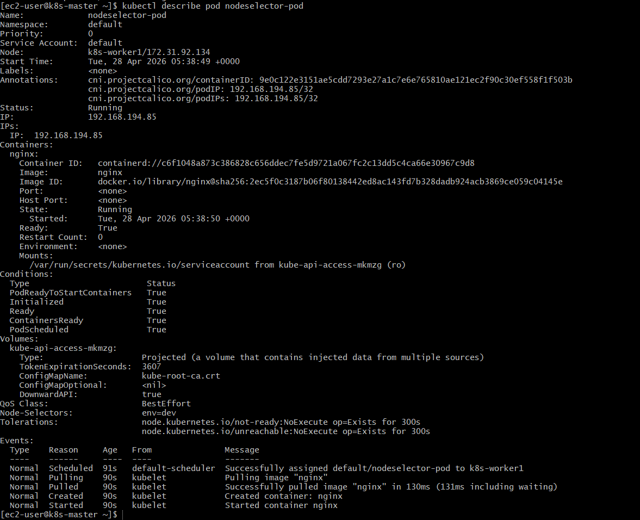

Important Behavior
If no node has label env=dev
Pod = Pending ❌
If multiple nodes have label
Scheduler chooses any one ✅

Concept
Feature | Purpose
Label | Tag node
NodeSelector | Match pod to node
Result | Pod runs only on matching node

Label = Tag
NodeSelector = Match

Cleanup (Optional)
kubectl delete pod nodeselector-pod
kubectl label nodes k8s-worker1 env-

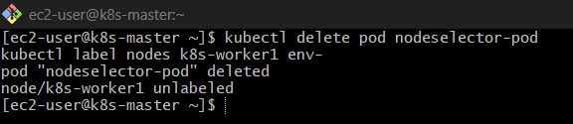

Task 4: Use Node Affinity with Soft Scheduling Label a node with env=test. Create a pod with PreferredDuringSchedulingIgnoredDuringExecution node affinity, preferring to schedule it on a node labeled env=test. Remove the label and verify the pod continues to run.

Task 4: Node Affinity (Soft Scheduling)

🔹 Step 1: Check Nodes
kubectl get nodes
Pick a node (example: k8s-worker1)
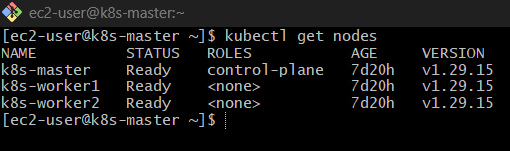

🔹 Step 2: Label the Node
kubectl label nodes k8s-worker1 env=test
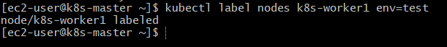

🔹 Step 3: Verify Label
kubectl get nodes --show-labels
Confirm:
env=test

🔹 Step 4: Create Pod with Soft Affinity
vi soft-affinity-pod.yaml
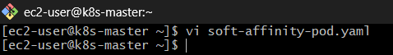
Paste this:
apiVersion: v1
kind: Pod
metadata:
name: soft-affinity-pod
spec:
containers:
- name: nginx
image: nginx
affinity:
nodeAffinity:
preferredDuringSchedulingIgnoredDuringExecution:
- weight: 1
preference:
matchExpressions:
- key: env
operator: In
values:
- test
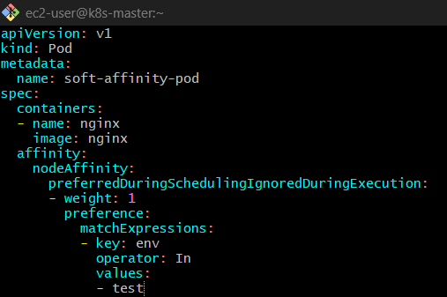

🔹 Step 5: Apply Pod
kubectl apply -f soft-affinity-pod.yaml
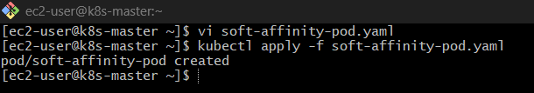

🔹 Step 6: Verify Scheduling
kubectl get pods -o wide
Expected:
soft-affinity-pod Running ... k8s-worker1 ✅
Because scheduler prefers env=test

Now the MAIN PART (Concept Test)
🔹 Step 7: Remove Label
kubectl label nodes k8s-worker1 env-
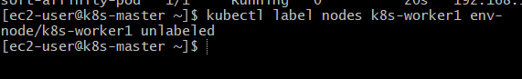
🔹 Step 8: Check Pod Again
kubectl get pods -o wide
Output:
soft-affinity-pod Running ✅
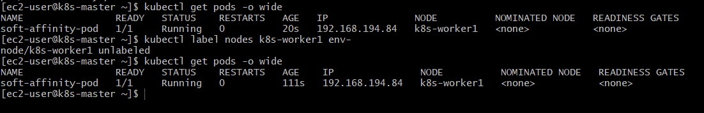

Why is pod still running?
Because of this:
IgnoredDuringExecution
Meaning:
- Rule is checked ONLY during scheduling
- After pod is running → Kubernetes does NOT evict it

Core Concept
Type |  |  | Behavior
preferredDuringScheduling |  |  | Soft rule (try best)
requiredDuringScheduling |  |  | Hard rule (must match)
IgnoredDuringExecution |  |  | No effect after scheduling

Preferred = Try
Required = Must
Ignored = Don’t care after run

What if label is removed BEFORE scheduling?
Pod will:
Still run (on any node) ✅
Because it's soft rule

Cleanup
kubectl delete pod soft-affinity-pod

Task 5: Implement Node Affinity with Hard Scheduling Create a pod with RequiredDuringSchedulingIgnoredDuringExecution node affinity, ensuring it will only be scheduled on a node labeled env=prod. Verify the pod cannot be scheduled if no node has the env=prod label.

Task 5: Node Affinity (Hard Scheduling)
🔹 Step 1: Check Nodes
kubectl get nodes
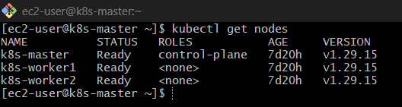
For now, DO NOT label any node with env=prod

Step 2: Create Pod YAML (Hard Rule)
vi hard-affinity-pod.yaml
Paste this:
apiVersion: v1
kind: Pod
metadata:
name: hard-affinity-pod
spec:
containers:
- name: nginx
image: nginx
affinity:
nodeAffinity:
requiredDuringSchedulingIgnoredDuringExecution:
nodeSelectorTerms:
- matchExpressions:
- key: env
operator: In
values:
- prod
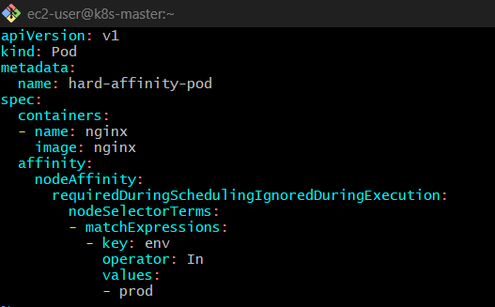

🔹 Step 3: Apply Pod
kubectl apply -f hard-affinity-pod.yaml
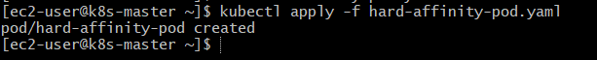

🔹 Step 4: Check Pod Status
kubectl get pods
Output:
hard-affinity-pod Pending ❌
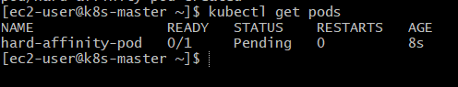

🔹 Step 5: Describe Pod (IMPORTANT)
kubectl describe pod hard-affinity-pod
You’ll see something like:
0/2 nodes are available: node(s) didn't match node affinity
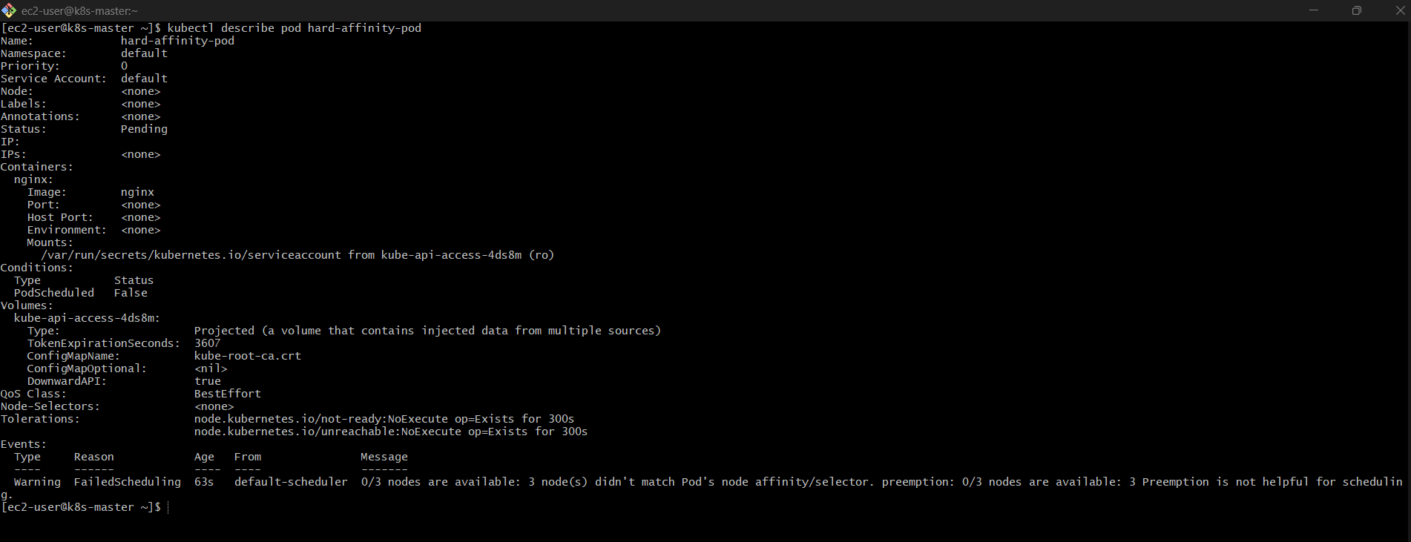

Why Pending?
Because:
- You said MUST have label env=prod
- But no node has that label
So scheduler says:
"I refuse to schedule this pod" ❌

Step 6: Fix by Adding Label
kubectl label nodes k8s-worker2 env=prod
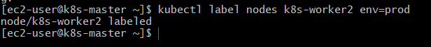

🔹 Step 7: Check Again
kubectl get pods -o wide
Now:
hard-affinity-pod Running ... k8s-worker2 ✅
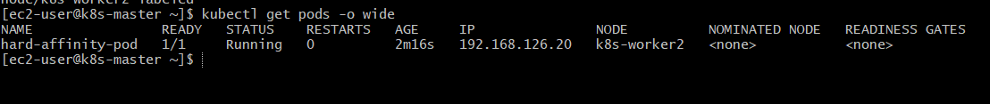
Step 8: Remove Label (After Running)
kubectl label nodes k8s-worker2 env-
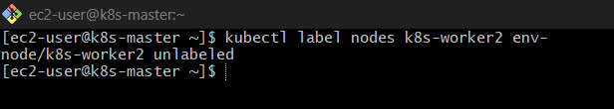
🔹 Step 9: Check Pod
kubectl get pods
Still:
Running ✅
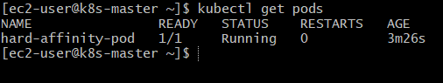
Why still running?
Because:
IgnoredDuringExecution
Same concept as before:
- Rule applies only at scheduling time
- After that → Kubernetes doesn’t care
Final Concept
Type | Behavior
RequiredDuringScheduling | MUST match
PreferredDuringScheduling | TRY to match
IgnoredDuringExecution | No eviction after running
Cleanup
kubectl delete pod hard-affinity-pod
kubectl label nodes k8s-worker2 env-

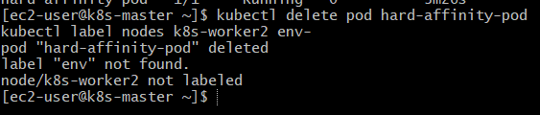

Task 6: Taint a Node and Use NoExecute with Toleration Seconds Taint a node with special=true:NoExecute. Create a pod with a tolerationSeconds field (e.g., 60 seconds) and observe it gets evicted after 60 seconds on the tainted node.

Task 6: NoExecute + tolerationSeconds
🔹 Step 1: Check Nodes
kubectl get nodes
Pick a node (example: k8s-worker2)
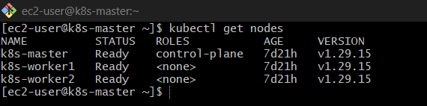

Step 2: Create Pod FIRST (important)
Why first?
Because NoExecute will evict existing pods too.
vi noexecute-pod.yaml
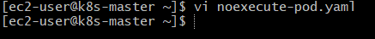
Paste:
apiVersion: v1
kind: Pod
metadata:
name: noexecute-pod
spec:
containers:
- name: nginx
image: nginx
tolerations:
- key: "special"
operator: "Equal"
value: "true"
effect: "NoExecute"
tolerationSeconds: 60
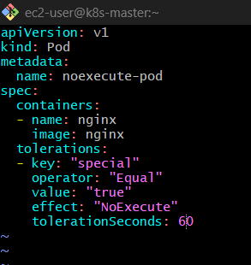

🔹 Step 3: Force Pod onto Node
Add nodeSelector (so it goes to same node you’ll taint)
nodeSelector:
kubernetes.io/hostname: k8s-worker2
Final YAML becomes:
apiVersion: v1
kind: Pod
metadata:
name: noexecute-pod
spec:
containers:
- name: nginx
image: nginx
nodeSelector:
kubernetes.io/hostname: k8s-worker2
tolerations:
- key: "special"
operator: "Equal"
value: "true"
effect: "NoExecute"
tolerationSeconds: 60
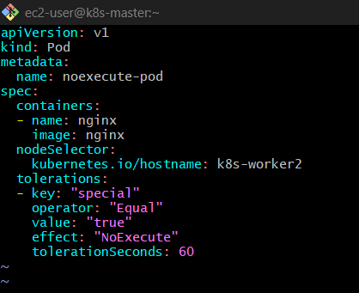

🔹 Step 4: Apply Pod
kubectl apply -f noexecute-pod.yaml
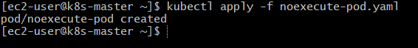

🔹 Step 5: Verify Running
kubectl get pods -o wide
Should be:
Running on k8s-worker2 ✅

Step 6: Apply Taint (MAIN ACTION)
kubectl taint nodes k8s-worker2 special=true:NoExecute
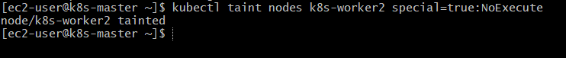

🔹 Step 7: Observe Behavior
Immediately after taint:
kubectl get pods -w
What happens:
Time | Status
0–60 sec | Running ✅
After 60 sec | Terminating → Deleted ❌
Pod gets evicted automatically
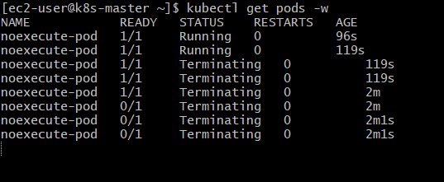

Why eviction happens?
Because:
tolerationSeconds: 60
Means:
“I can tolerate this taint ONLY for 60 seconds”

Core Concept
Effect |  |  |  | Behavior
NoSchedule |  |  |  | Blocks new pods
NoExecute |  |  |  | Evicts existing pods
tolerationSeconds |  |  |  | Delay eviction

Special Cases
❌ No toleration
Immediate eviction
✅ Toleration without seconds
tolerationSeconds: NOT given
Pod stays forever (no eviction)

NoExecute = Kick out pods
tolerationSeconds = “Wait 60 sec ”

Cleanup
kubectl delete pod noexecute-pod
kubectl taint nodes k8s-worker2 special=true:NoExecute-
